# MQ7 SENSOR TO DETECT AND MONITOR THE AIR QUALITY USING ARDUINO UNO

Nursyafira binti Mohd Nasir Ali, EG2227 [nrsyfra2002@gmail.com](mailto:nrayfra2002@gmail.com) ,01164287410

MARA-Japan Industrial Institute,2022

In this methodology, you will learn how to upload a program or code written in Arduino IDE using Arduino language plus with basic C programming to your Arduino that connected to MQ7 Sensor and others component to make it a simple circuit. There are a few ways that can be done to do that but, in this tutorial, we will be using Arduino UNO board to code it.

By following all the steps mentioned in this tutorial consecutively, you will just take about 30 to 60 minutes to successfully upload your written code into the Arduino UNO and completely do the circuit.

# Pre-requisite

1. You must be familiar with Arduino IDE, and already installed it in your PC/Laptops.
2. You should have skill to read a schematic and build the circuit from the schematics.

# Required Materials

|  |  |  |  |
| --- | --- | --- | --- |
| 1 | Arduino Board | Arduino UNO | 1 |
| 2 | LCD Display | JHD162A 16X2 LCD Display | 1 |
| 3 | MQ7 Sensor | Carbon Monoxide | 1 |
| 4 | Buzzer | 5V Active Buzzer | 1 |
| 5 | LED | 5mm LED any Color | 2 |
| 6 | Connecting Wires | Jumper Wires | 10-20 |
| 7 | DC Fan | - | 1 |
| 8 | Breadboard | - | 1 |

# Step Procedures

1. Install Arduino IDE.
   1. Download the very latest version at [https://downloads.arduino.cc/arduino-1.8.19-](https://downloads.arduino.cc/arduino-1.8.19-windows.zip?_gl=1%2Abiyby8%2A_ga%2AMTYyNDg4MzQ4MS4xNjYzNDAwODU2%2A_ga_NEXN8H46L5%2AMTY2NjE5NzU5MC4xOC4xLjE2NjYxOTc1OTMuMC4wLjA)

[windows.zip?_gl=1*biyby8*_ga*MTYyNDg4MzQ4MS4xNjYzNDAwODU2*](https://downloads.arduino.cc/arduino-1.8.19-windows.zip?_gl=1%2Abiyby8%2A_ga%2AMTYyNDg4MzQ4MS4xNjYzNDAwODU2%2A_ga_NEXN8H46L5%2AMTY2NjE5NzU5MC4xOC4xLjE2NjYxOTc1OTMuMC4wLjA)

[_ga_NEXN8H46L5*MTY2NjE5NzU5MC4xOC4xLjE2NjYxOTc1OTMuMC4](https://downloads.arduino.cc/arduino-1.8.19-windows.zip?_gl=1%2Abiyby8%2A_ga%2AMTYyNDg4MzQ4MS4xNjYzNDAwODU2%2A_ga_NEXN8H46L5%2AMTY2NjE5NzU5MC4xOC4xLjE2NjYxOTc1OTMuMC4wLjA)

[wLjA](https://downloads.arduino.cc/arduino-1.8.19-windows.zip?_gl=1%2Abiyby8%2A_ga%2AMTYyNDg4MzQ4MS4xNjYzNDAwODU2%2A_ga_NEXN8H46L5%2AMTY2NjE5NzU5MC4xOC4xLjE2NjYxOTc1OTMuMC4wLjA).

*Notes: Click ‘Just Download’ to directly download the zip file.*

* 1. 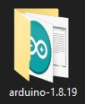Icon

     Description automatically generatedExtract the downloaded zip file.
  2. Right click and then select *Run as administrator* to install the file name “arduino”.

*Notes: 1.8.19 is the latest version during the time preparing this worksheet.*

* 1. During installation, it might ask permission to install some drivers for Arduino port. Allow all the necessary permission.
  2. After complete installation, ensure that you create a shortcut of “Arduino” file in the desktop.

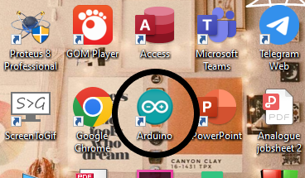

1. Wiring the MQ7 Sensor according to the following circuit diagram.

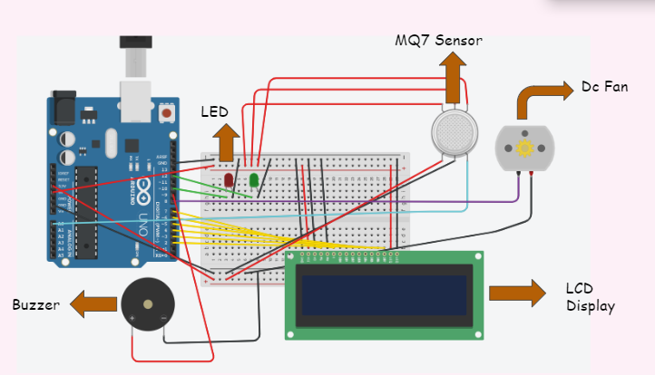

Figure 1

1. Connect the LCD Displayas shown in **Figure 1** on the breadboard. The circuit will look like this:

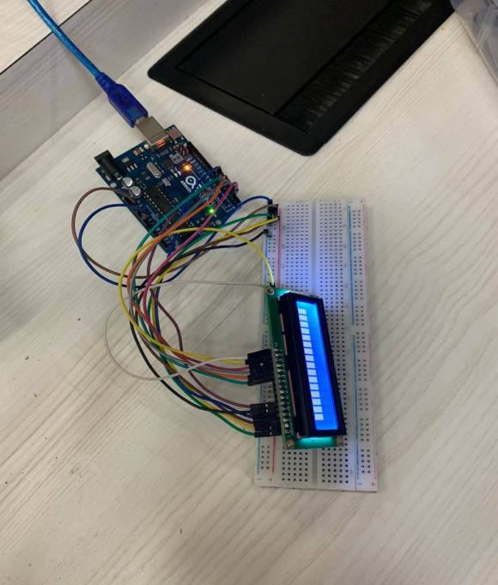

*Notes: When you give supply to the circuit and the connection*

*is correct the LCD will power on like the picture.*

1. Next, connect the **MICROCONTROLLER PART** as shown in **Figure 1** Carefully make the connections.
2. Now, connect the microcontroller to the PC/Laptop by using USB cable for UNO. Your final circuit will look like this:

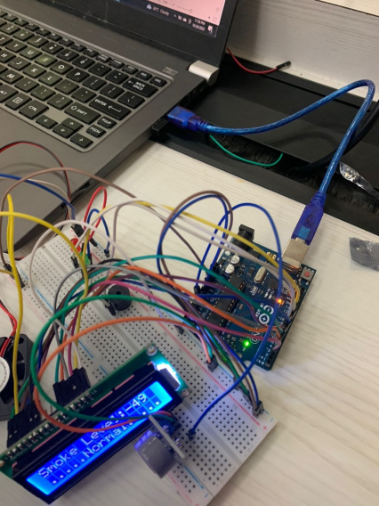

*Notes: When you give supply to the circuit, LCD will*

*display the status of the air surrounding*

**MQ7 Sensor.**

To control MQ7 Sensor, I used Arduino IDE software to program the code into Arduino UNO

* 1. **Step 1:** Using coding that were given, now you can test your function. Also, make sure your com port and board are true as below:

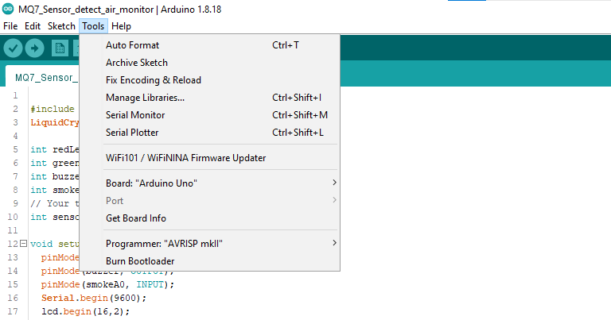

*Notes: Com port is depending on your computer/laptop. Then, just hit the verify button.*

* 1. **Step 3:** After **verify**, and there is no any error in your coding, you can connect your Arduino UNO with the circuit board to you PC/laptop.

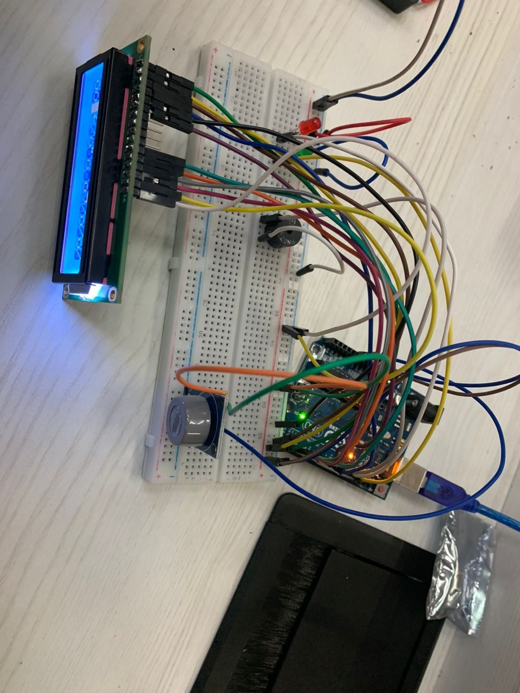

* 1. **Step 4:** Circuit will display the output

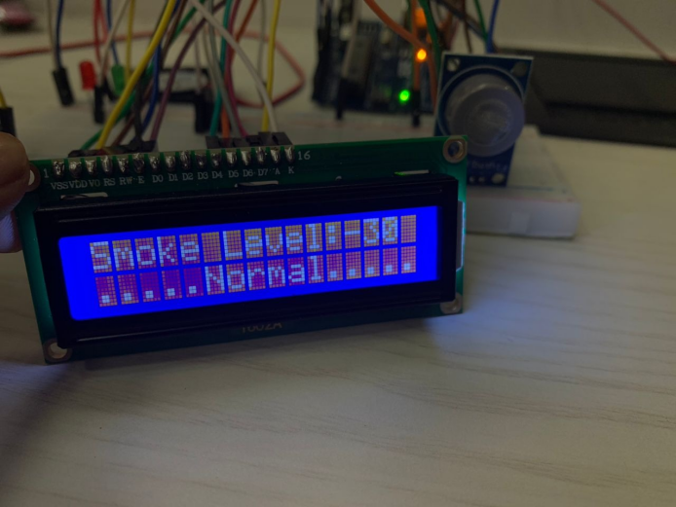

1. Write the following code to upload to the circuit

#include <LiquidCrystal.h>

LiquidCrystal lcd(7, 6, 5, 4, 3, 2);

int redLed = 10;

int greenLed = 12;

int buzzer = 8;

int smokeA0 = A0;

// Your threshold value

int sensorThres = 100;

void setup () {

pinMode(redLed, OUTPUT);

pinMode(buzzer, OUTPUT);

pinMode(smokeA0, INPUT);

Serial.Begin(9600);

lcd.Begin(16,2);

}

void loop() {

int analogSensor = analogRead(smokeA0);

Serial.print("Pin A0: ");

Serial.println(analogSensor);

lcd.print("Smoke Level:");

lcd.print(analogSensor-50);

// Checks if it has reached the threshold value

if (analogSensor-50 > sensorThres)

{

digitalWrite(redLed, HIGH);

lcd.setCursor(0, 2);

lcd.print("Alert....!!!");

digitalWrite(12, LOW);

tone(buzzer, 1000, 200);

}

else

{

digitalWrite(redLed, LOW);

digitalWrite(12, HIGH);

lcd.setCursor(0, 2);

lcd.print(".....Normal.....");

noTone(buzzer);

}

delay(500);

lcd.clear();

}

1. Connect the Arduino Board to the PC/Laptop. Open Arduino IDE.



1. Click on **‘Upload’** button and the Arduino IDE will start to compile the code. It will take few moments to complete the compiling.

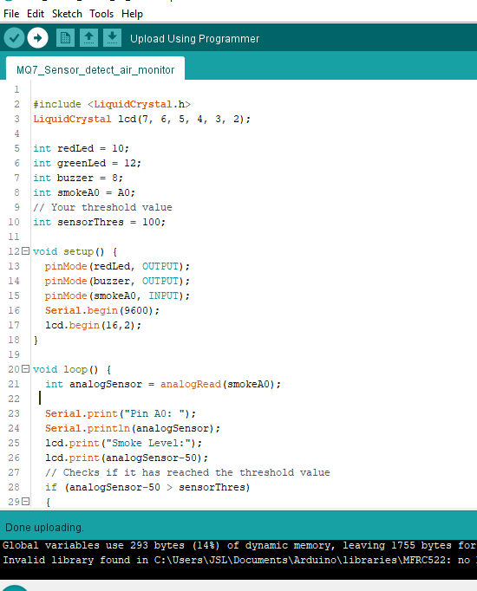

1. After compilation is done successful, you will see the motor move and the speed control by the push button.
2. Finished

# Important Notes

1. Every time you want to change the component, make you disconnected Arduino from you laptop or PC.
2. If your components are still new, test each component before compile it together.